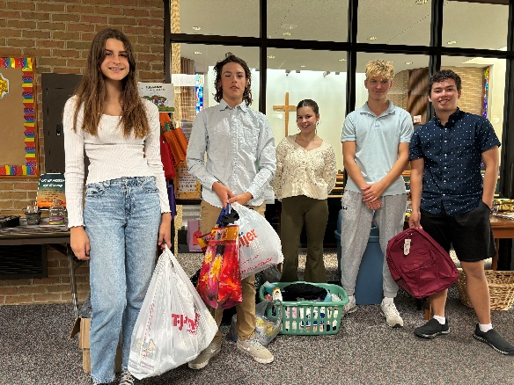 **October 2024**

**10/6 – 20th Sunday of Pentecost**

**Potluck followed by Music Recital after church**

**10/13 – 21st Sunday of Pentecost**

**HS class meets after church**

**10/20 – 22nd Sunday of Pentecost – Fall Fest Bonfire**

**Meet at Brenda Steven’s House 4-6 pm for dinner, games, and bonfire**

**10/27 – Reformation Sunday**

**HS class meets after church**

**God’s Work our Hands:**

**Personal Item Drive:** Thank you to the congregation for donating over 500 items plus a generous financial donation to the Talawanda schools and to Annie Caudill for taking the lead to organize this drive. Thank you our High School class for taking inventory of the items. We are off to a great start.

**Fall Fest Bonfire:** Save the date for a fun afternoon outside visiting, playing games and roasting marshmallows. More details to come.

**Evening Zoom Bible Study:** Our current study is meeting on Wednesday nights at 6:30 pm studying the book of Esther. Esther is one of two books in the Bible that do not mention God’s name. However, God’s hand is present all through the book as we see God’s sovereignty and how he uses world events in His perfect plan for His glory. Contact Micheline Kidwell (mmkidwell@gmail.com) for more information.

**Wednesday Morning Bible Study:** Wednesday morning Bible Study meeting at Faith will resume this soon. Please contact Beth Baer (BAERME@muohio.edu) for more information.